**Design Phase**

**10 Common uses for Spreadsheets**

* The preparation of annual accounts for businesses
* Trading Profit and Loss Account
* Balance Sheet
* The preparation of Business documents
* Tables within Invoices
* Quotations
* Statements
* The preparation of various budgets
* Cash Budget
* Purchasing Budget
* Sales Budgets
* For calculating wages
* Hours Worked
* Pay per hour
* Taxation Calculations
* Take home pay
* To calculate grades of students
* Marks
* Transfer to percentages
* Transfer to grades Eg A B C
* Preparing Income and Expenditure accounts
* Time Sheets
* To calculate different scenarios that have been predicted.
* Using Spreadsheets for “What if Statement” or “Sensitivity Analysis”
* To create charts
* such as pie charts and bar charts

* To calculate mathematical problems and equations
* E.g. Statistical Analysis i.e. Mode Median Mean

**A concise description of the problem and a proposed solution identifying a source of data**

The company Glaise Limited wants to bill Germinal Seeds for the use of its courier’s service. To bill this customer I will write an invoice to send to a customer from Glaise Ltd for work done over the period of a month. Make sure you charge them at 1.5x the normal rate for night work. Every pallet delivered has a charge of € 30. The customer is Germinal Seeds in Horse and Jockey.

**Aims of the project**

* To create an invoice for Customer: Germinal Seeds.
* To have an invoice that is easy to read and follow.
* For the customer to know what they owe, why they owe it and how they owe the amount they are being charged.
* To state all the information relating to the bill precisely and in order.
* To have an invoice that can be understood by the customer
* To help the accountant to understand what has been charged and what is owed
* To provide a factual bill.
* To inform the customer of the date they need to have paid by.
* To inform the customer that if does not pay on time they will know the penalty for it.
* To show all the docket numbers associated with this invoice.

**Demonstrate 10 common spreadsheet usability features to include use of toolbars and window management e.g. that you will use within your project.**

In this project I will use several functions that are common in spreadsheets.

* I will use AUTOSUM- To calculate the sum of two numbers such at the Net Cost and VAT to find the Total Cost.
* I will use the IF Function- To calculate a value of the quantity depending on if it reaches the requirements or not.
* I will use the Average Function-To show the customer what the average cost of the service Glaise Limited provides is.
* I will use the Min Function-To show the customer what the lowest price of any delivery done by the service that was provided was.
* I will use the Max Function-To show the customer what the highest price of any delivery done by the service provided. When combined with the Min function we find out the range of cost depending on the delivery.
* I will use the percentage Accounting Number Format- To show the VAT Rate.
* The minus symbol is used to allow the user to construct a formula that subtracts one value from another value.
* The use of the multiplication symbol to allow the user to construct a formula that multiplies two different numbers.
* The use of Italic, Underline, Bold and Highlight to emphases a word or number. It is often used for answers or headings.
* Graphing- This is used to give the reader a visual aid when understanding what the spreadsheet has been used for.

**Specifications for input data, processing required and output data**

I will have a heading called Glaise Limited and it will be designed like this;



For the address of both the company I will send to and the company that is sending the invoice I will design it in this format;

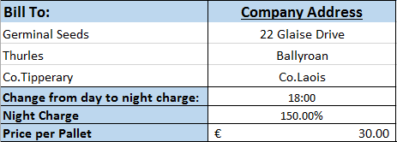

To have a well-designed invoice I will have sub headings called, Description, Quantity, Date, Time, Net amount, Vat and Total Cost. It will look like this;



The data I will input in the spreadsheet will be for the sub headings: Description, Quantity and VAT. It will look like this;

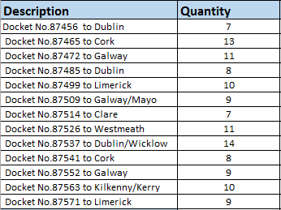 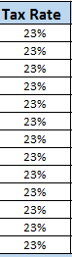

I will have an Other Comments Sub heading and under that it will say: Please pay by Bank Transfer to this account and have the bank details. It will look like this;

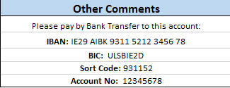

**Specifications of format for all data e.g. alignments, column widths**

**Output data**

Formulas I used:

* =DATE(2016,11,1)
* =TIME(10,30,0)
* =IF(D10>$B$6,(B10*$B$8)*$B$7,B10*$B$8)
* =NPV(0,E10:E22)
* =(B23*F10)
* =SUM(B23+B24)
* =MAX(G10:G22)
* =MIN(G10:G22)
* =AVERAGE(G10:G22)
* =B25+ (B25*10%)
* =(E21*F21)+E21

**A design for a data capture form and the screen layout**

**Data Capture Form: Docket Sheet**

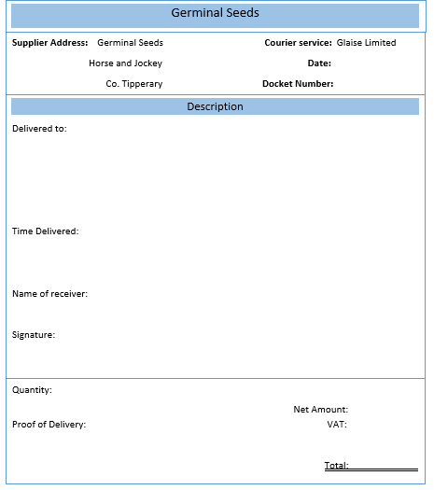

**Screen Layout (Transfer your screen and colour code the cells)**

**COLOUR CODE**

**INPUT DATA**

**OUTPUT DATA**

**CONSTANT DATA**

**HEADINGS**

**PENALTY**

**A concise description of the proposed macro**

For my macro I will record the template for my project. I will include all of the main headings in their correct cell box. Such as having Description(),Quantity() ,Date() ,Time() ,Net amount() , Vat Rate() and Total().

**A concise description of the proposed graph**

The graph I will use is called a stacked column graph. The x-axis will be used to show every docket sheet. The y-axis will have the cost. The cost will be in euros and will go from € 0 – € 900. The graph will have 12 columns of different lengths depending on how much each docket cost.

**Specification of where filtering will be used in the assignment**

I will filter the Dublin based deliveries into one line. To have the invoice more precise and condensed. I chose Dublin because the deliveries went to Dublin more than any other place.